****e

**Patient Information Leaflet**

Telephone No:02476685918

Email address: crccg,edgwickmedicalcentre@nhs.net

Website: <https://www.edgwickmedicalcentre.nhs.uk>

**How to register at the practice**

You must live within the practice area which is shown on the website. If you are unable to use the website, please contact the practice for information about how to register.

**Patients’ rights and responsibilities**

When registering, you have a right to express a preference to be seen by a particular GP. This will be recorded on our clinical system and, where possible, you will be allocated appointments with that clinician. All patients will be assigned an accountable GP.

You will also be offered a health check when you join the practice for the first time (see the practice website for a full list of your rights and responsibilities).

**Disabled Access**

Our practice has suitable access for disabled patients, and all the patients’ areas including waiting rooms, consulting rooms, and toilets have wheelchair access. A hearing loop is in place at the front reception desk, and we also have a lift providing access to all our floors.

A designated disabled parking space is located in our car park nearest to the front entrance door.

40

**Services we provide**

Along with routine appointments, the practice offers the following services:

* **Family planning –**  We offer a full range of family planning services
* **Immunisations –** The nursing team administers vaccines for both adult and child immunisations. We hold set vaccination clinics. If you are unable to attend these clinics, please discuss with a member of our administrative staff
* **Minor surgery – Joint injections are provided by GP.**
* **Cervical smear testing –** For women aged 25 – 65. These tests are undertaken by the nursing team.
* **Weight management clinics-**Run by well-being coach these clinics are aimed at encouraging a healthy lifestyle for our male and female population.
* **Chronic disease management –** We hold regular clinics with our diabetic specialist nurse to help our patients to manage their diabetes.
* **Other services –** Health checks for adult patients aged 16 to 74 years and 75 years and over are also available especially for those who have not seen a clinician at this practice. Details are available from reception and on the practice website.
* **Travel vaccinations-** Nurse led clinics to advice and offer travel vaccinations
* **Baby checks and postnatal checks for baby and mum respectively**
* **Antenatal clinics-Provided weekly by the midwives**

We also offer the following clinics and checks: antenatal, baby and post-natal,

From time to time, other services may be available such as raising awareness of a particular disease or condition. We will advertise this information on our website and within the practice.

**Patient Information Leaflet**

[

Telephone No:02476685918

Email address: crccg,edgwickmedicalcentre@nhs.net

Website: <https://www.edgwickmedicalcentre.nhs.uk>

**Opening hours**

|  |  |  |
| --- | --- | --- |
| Mon–Friday | 8:30 am | 6 pm |

**Please note we remain open during 1pm – 2pm**

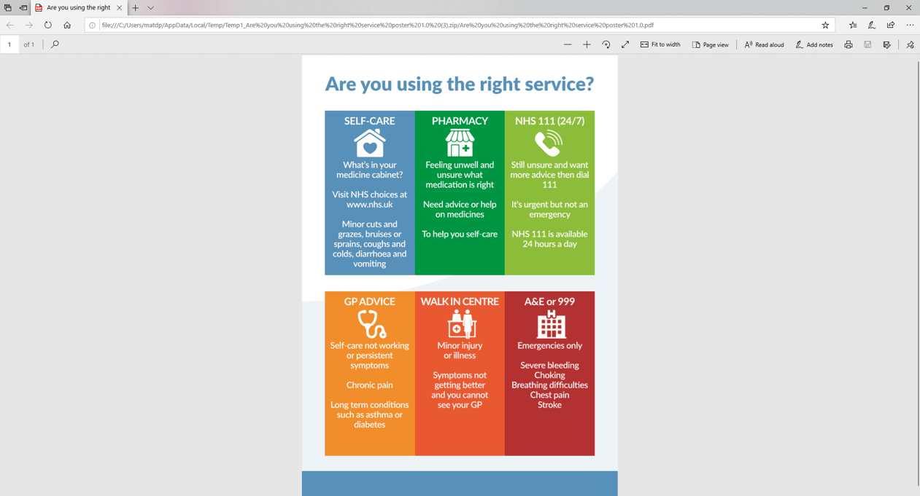

**Online appointments and accessing practice services**

To request a admin related problem or a non-urgent appointment to see your GP or any member of our healthcare staff or to access any other of our practice services, please log on to the practice website at <https://www.edgwickmedicalcentre.nhs.uk>

**Online Access**

The Practice is pleased to provide patients with access to its Clinical System via a Secure Web Interface.

To use **Patient Access** you will need a Practice ID number and Access ID number which is obtained from the practice, and, in conjunction with a password, will be unique to you.

The practice website contains all the relevant practice information that you are likely to require. It is the quickest way to access the services you may need.

**Improved access/Extended hours / Community Pharmacy appointments.**

We offer extended access / hours appointments at other GP Branches – please enquire with our receptionist if you require an appointment.

**Threats of violence or abuse of our staff**

Our staff work hard to provide you with the best possible service. Please treat them with the courtesy and respect they deserve. We operate a zero-tolerance policy and may refuse to provide services to individuals or those accompanying individuals who are violent, threaten violence, commit or threaten to commit a criminal offence

**Patient** **Participation Group**

Edgwick Medical Centre has a Patient Panel Group which meets regularly at the practice. This voluntary group of patients work in partnership with all staff and Doctors, to help improve the delivery of services and to improve the patient experience. If you would like to know more about this group, or want to join, please talk to a member of staff.

**Patient data**

All clinical and administrative staff have an ethical as well as a legal duty to protect patient information from unauthorised disclosure and in accordance with UK GDPR.

The patient privacy notice is available on the practice website.

If you have any special communication or accessibility needs, please let our reception team know and we will do our best to assist you.

We also offer a quiet room for our autistic patients or anyone who might benefit from a calm and low-stimulation environment. Please ask at reception if you would like to use it.

Your health and care matter to Edgwick.

**NHS England Contact**

Edgwick Medical Centre provides NHS services on behalf of NHS England, PO Box 16738, Redditch, B97 9PT.

Telephone: 0300 311 2233

Email: [england.contactus@nhs.net](mailto:england.contactus@nhs.net)

**Prescriptions/repeat prescriptions.**

Your GP will initiate any prescription that they determine you require. Repeat prescriptions can be ordered in the following ways:

* In person – By ticking the required medications on your prescription and placing it in the dedicated box, located in reception.
* By telephone – Please call the practice on [02476685918, pressing option 2 between the hours of 10am and 12.

**Please allow [48 hours] for collection (excluding weekends and bank holidays) when ordering repeat prescriptions.**

**General enquiries**

Please call 02476685918 and press option 3 for all general inquiries and your call will be picked up by our administration Team.

end

**Comments, suggestions and complaints**

If you would like more information about any of the services we provide, please ask a member of staff, telephone or log into the practice website. Details are shown on the front of this leaflet.

Our aim is to give the highest possible standard of service. We would like you to tell us what you think about the service we

**Home visits**

Home visits are at the discretion of the GPs and are usually for those patients who are housebound or have significant health issues. Contact reception requesting a call-back after logging a call [before 10.00 am]. A clinician will then telephone you to discuss your request.

Home visits are Monday to Friday and not over the weekends.

**When we are closed**

When the practice is closed, if you urgently need medical help or advice and it is life threatening, dial 999. If it is not life-threatening, contact NHS 111 by calling 111 or accessing via [www.nhs.uk](http://www.nhs.uk)

**Edgwick Clinical team**Welcome to our Practice

**GP’s**

**Dr Meera Pillai**

**Job Title: General Practitioner**

**Dr Preetha Thulasidasan**

**Job Title: General Practitioner**

**Dr Prashant Sadh**

**Job Title: General Practitioner**

**Dr Afuwape Ibidiolapo**

**Job Title: General Practitioner**

**Other Clinical roles**

**Mr Raghbir Sahota**

**Clinical Pharmacist**

**Mr Suraj Kumar**

**Physician Associate**

**Mr Peter Zeh**

**Advanced Nurse Practitioner**

**Bhupinder Pawar**

**Advanced Nurse Practitioner**

**Physiotherapist**

**Fiona Dove**

**Mr Jarmajit Singh**

**Nurses**

**Miss Alison Evans**

**Practice Nurse**

**Miss Fatima Mulla**

**Health Care Assistant**

**Midwife**

**Antenatal clinics**